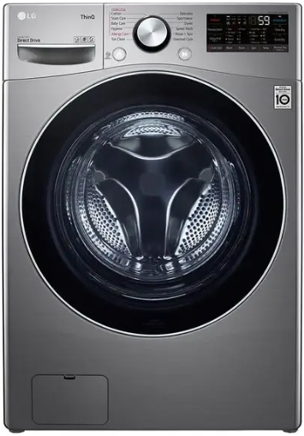

LG Washer Dryer
Rs.203,105
LG front load washer dryer F15L9DGD combines a 13 kg washer, 8 kg dryer, AI DD fabric care, Turbo Wash, steam technology, and Thin Q connectivity.

Specifications
- Model: F15L9DGD
- Wash Capacity: 13 kg
- Dry Capacity: 8 kg
- Smart Control: LG ThinQ

Key Features
- AI DD fabric sensing
- Turbo Wash
- Steam care
- Smart diagnosis

